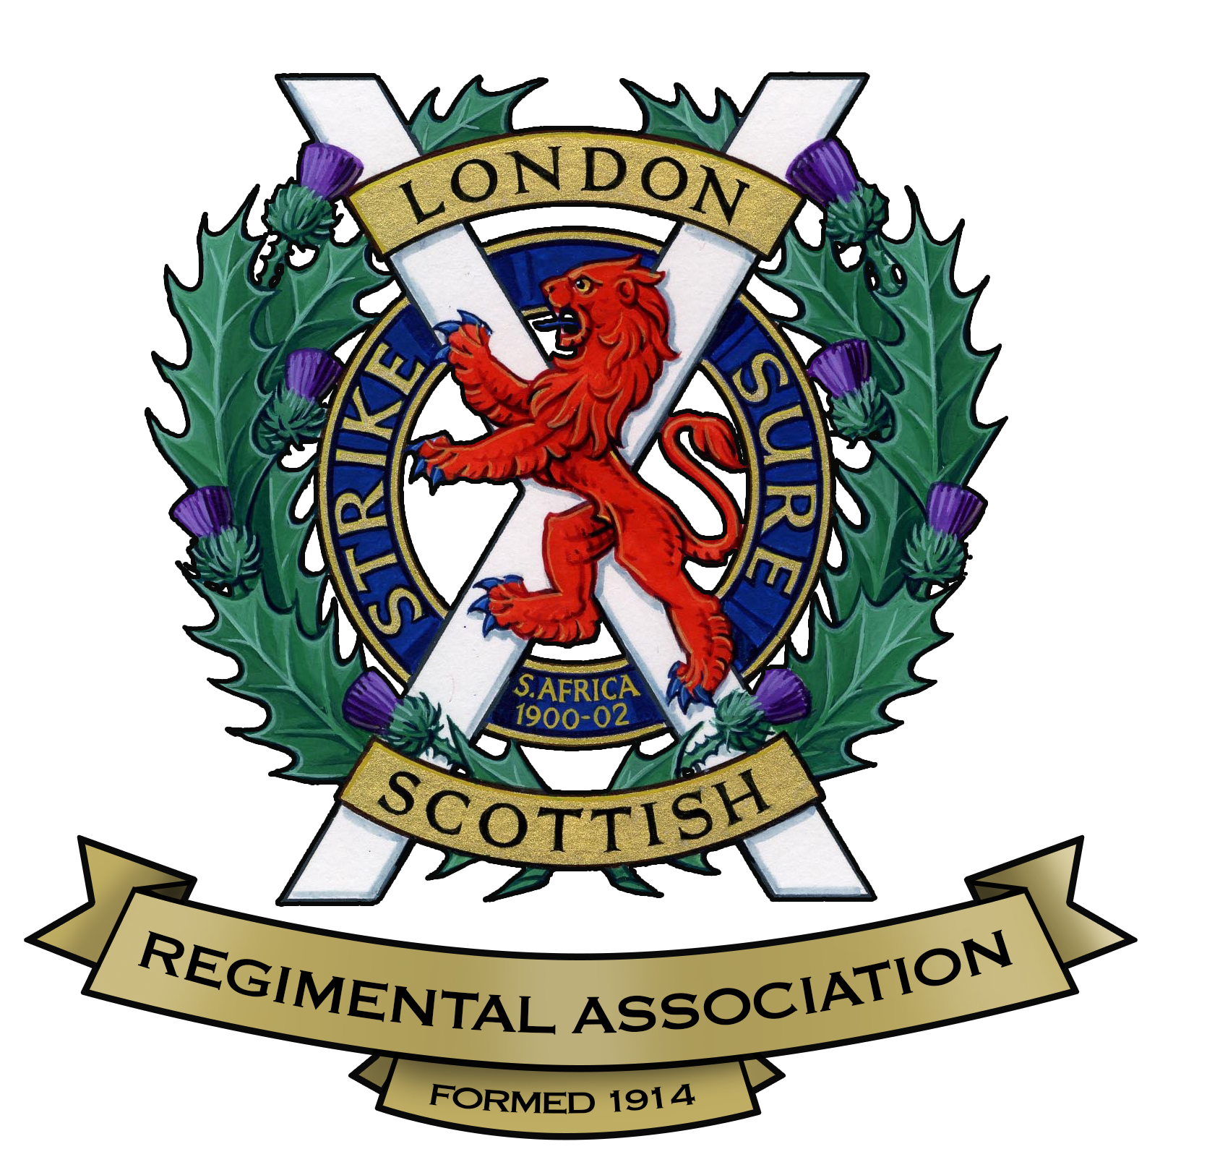

LONDON SCOTTISH REGIMENTAL ASSOCIATION

APPLICATION FOR MEMBERSHIP

(SERVING COMPANY)

The objects of the London Scottish Regimental Association are:-
- To preserve that spirit of comradeship which exists and has always existed amongst all ranks of the London Scottish Regiment, and to keep in touch with members overseas.
- To promote the well being of serving units and sub-units of the London Scottish Regiment and units and sub-units bearing that name in their title, especially as regards recruiting.
- To provide opportunities for reunions and other social and military gatherings.
- To provide a channel of communication with the various Benevolent and other Funds for members and their dependents in need of assistance.

I am applying to become a member of the London Scottish Regimental Association and agree that the Association will retain my personal information in accordance with the GDPR Policy of the Association.

Name……………………………………………………………………………………………………

Address…………………………………………………………………………………………………

Tel No. ……………………………………… E-mail address……………………………………….

Date Joined LS …………. Army No.………..………… Rank………..……… DOB……………

Date of Discharge……………… Decorations……………………………………………………....

Service in other units…………………………………………………………………………………...

…………………………………………………………………………………………………………….

…………………………………………………………………………………………………………….…………………………………………………………………………………………………………….

Signature ……………………………………………………………………….. Date ……………..

LSRA Members are entitled to full benefits including attending functions, events, reunions, battlefield tours and receipt of the Regimental Gazette. It is customary for members to attend headquarters on the 1st Tuesday of each month.

ONCE COMPLETED PLEASE SEND TO THE HONORARY SECRETARY:

By Post -
Martin Felstead, 41 Carlton Road, Walton-on-Thames, Surrey, KT12 2DF

By email -
mjfelstead99@gmail.com

v.20190219

